Network Security Threats and Countermeasures
1. Introduction
In today’s interconnected digital environment, network security plays a vital role in protecting data, systems, and communication channels from cyber threats. Organizations rely heavily on secure networks to maintain confidentiality, integrity, and availability of information. However, attackers continuously develop sophisticated techniques to exploit vulnerabilities.
This document provides a comprehensive overview of major network security threats, explains how they operate, analyzes their impact, and outlines effective countermeasures to mitigate risks.

2. Denial-of-Service (DoS) and Distributed Denial-of-Service (DDoS) Attacks
2.1 Definition
A Denial-of-Service (DoS) attack aims to make a system or network resource unavailable to legitimate users by overwhelming it with excessive traffic or requests.
A Distributed Denial-of-Service (DDoS) attack is a more advanced form where multiple compromised devices (botnets) simultaneously attack a target.

2.2 How It Works
- Attackers send a massive volume of traffic to a server.
- The server’s resources (CPU, memory, bandwidth) become exhausted.
- Legitimate users experience slow performance or complete service outage.
Common types include:
- SYN Flood attacks
- UDP Flood attacks
- HTTP Flood attacks
- DNS Amplification attacks

2.3 Impact
- Service downtime
- Financial losses
- Reputational damage
- Reduced customer trust
- Increased recovery costs

2.4 Countermeasures
- Deploy firewalls and intrusion prevention systems (IPS)
- Implement rate limiting
- Use DDoS protection services
- Network traffic monitoring and anomaly detection
- Load balancing and redundancy
- Keep infrastructure updated and patched
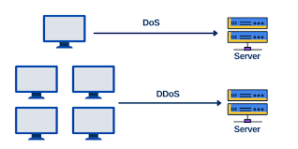

3. Man-in-the-Middle (MITM) Attacks
3.1 Definition
A Man-in-the-Middle (MITM) attack occurs when an attacker intercepts communication between two parties without their knowledge. The attacker may eavesdrop, modify, or inject malicious data.

3.2 How It Works
- The victim connects to a compromised or unsecured network.
- The attacker positions themselves between the victim and the intended server.
- All transmitted data passes through the attacker.
Common techniques include:
- ARP spoofing
- DNS spoofing
- Session hijacking
- Rogue Wi-Fi access points

3.3 Impact
- Theft of login credentials
- Financial fraud
- Data manipulation
- Exposure of confidential information
- Identity theft

3.4 Countermeasures
- Enforce HTTPS using SSL/TLS encryption
- Use Virtual Private Networks (VPNs)
- Enable multi-factor authentication (MFA)
- Avoid unsecured public Wi-Fi networks
- Implement certificate validation and pinning
- Secure DNS configurations (DNSSEC)
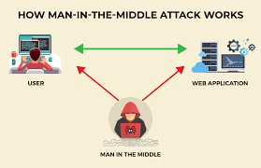

4. Spoofing Attacks
4.1 Definition
Spoofing is a cyberattack technique in which an attacker impersonates a trusted source by falsifying data such as IP addresses, email headers, or DNS records.

4.2 Types of Spoofing
- IP Spoofing
- Email Spoofing
- ARP Spoofing
- DNS Spoofing

4.3 How It Works
The attacker manipulates packet headers or identity credentials to appear legitimate. This deception tricks users or systems into trusting malicious communication.
Examples:
- Phishing emails appearing to come from trusted organizations
- Forged IP packets bypassing filters
- Fake DNS responses redirecting users to malicious websites

4.4 Impact
- Phishing campaigns
- Malware distribution
- Unauthorized network access
- Data breaches
- Financial theft

4.5 Countermeasures
- Implement SPF, DKIM, and DMARC for email authentication
- Use anti-spoofing firewall rules
- Enable packet filtering
- Conduct employee security awareness training
- Monitor logs and unusual network behavior
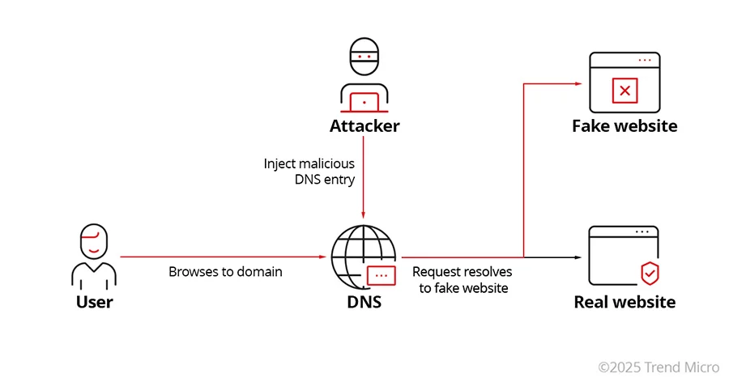

5. Additional Common Network Threats
5.1 Phishing
Fraudulent attempts to obtain sensitive information through deceptive emails or websites.
Mitigation: User awareness training, email filtering, and MFA.

5.2 Malware and Ransomware
Malware includes malicious software designed to damage or disrupt systems. Ransomware encrypts files and demands payment for decryption.
Mitigation:
- Regular backups
- Endpoint protection software
- System patching
- Access control policies

6. Importance of a Layered Security Approach
No single security solution can protect against all threats. A layered security model, also known as “defense in depth,” ensures multiple protective mechanisms are in place.
Key components include:
- Firewalls
- Intrusion Detection/Prevention Systems (IDS/IPS)
- Encryption
- Strong authentication mechanisms
- Network segmentation
- Continuous monitoring
- Regular vulnerability assessments
This approach minimizes the attack surface and reduces the likelihood of successful exploitation.

7. Best Practices for Network Security
- Keep software and systems updated
- Enforce strong password policies
- Enable multi-factor authentication
- Monitor network traffic continuously
- Conduct periodic security audits
- Train employees on cybersecurity awareness
- Implement least privilege access control

8. Conclusion
Network security threats such as DoS attacks, MITM attacks, and spoofing present serious risks to organizations and individuals. These threats exploit technical vulnerabilities and human weaknesses to compromise systems and data.
Understanding how these attacks work is essential for implementing effective countermeasures. A proactive and layered security strategy that combines technology, policy, and user awareness is critical to maintaining secure and resilient network infrastructure.
By adopting proper security controls and continuously monitoring emerging threats, organizations can significantly reduce risks and ensure the confidentiality, integrity, and availability of their network systems.

